**The Ark Documentation.**

**Add new subject: correspondence.**

Once you have seen the confirmation message that the new subject has been created, you can proceed to add information on correspondence.

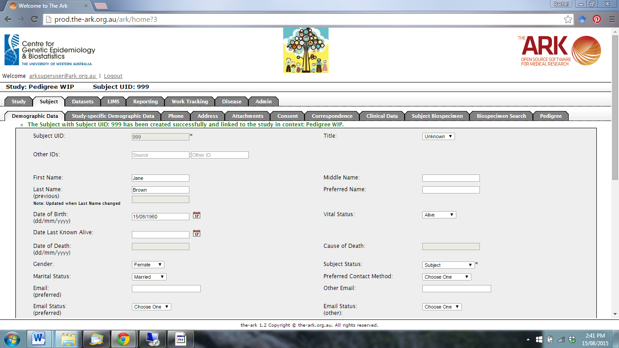

Click on the Correspondence function.

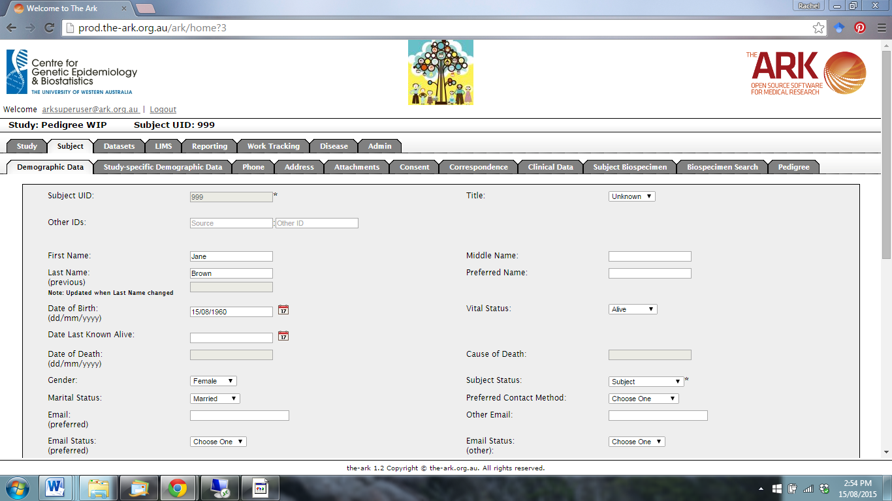

The following page will appear. Click new.

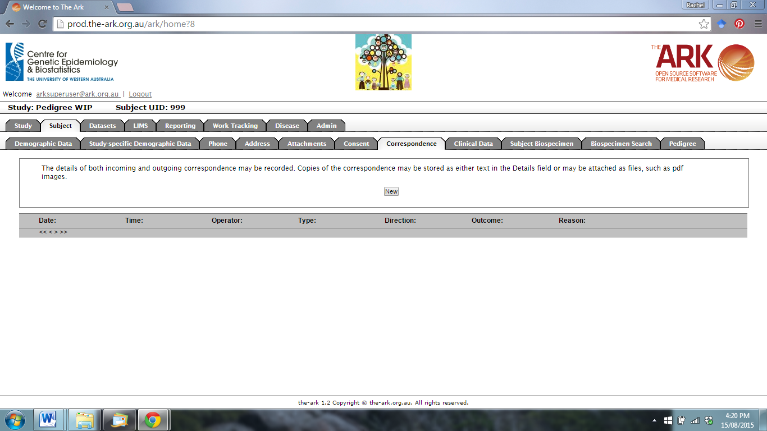

The following page will appear.

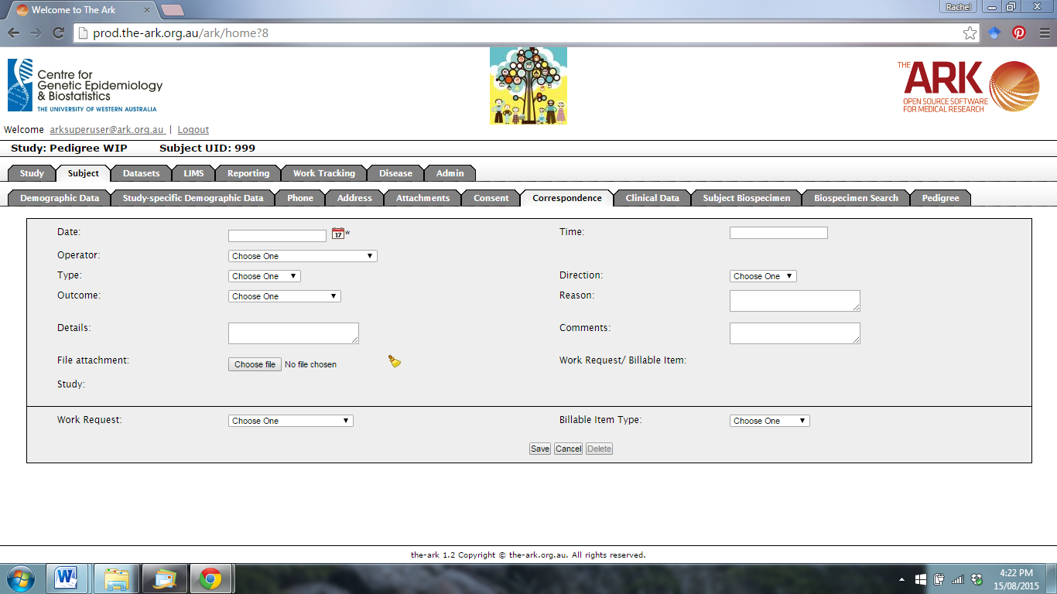

Use the drop-down menus to add correspondence information. You can add files by clicking on the Choose File function.

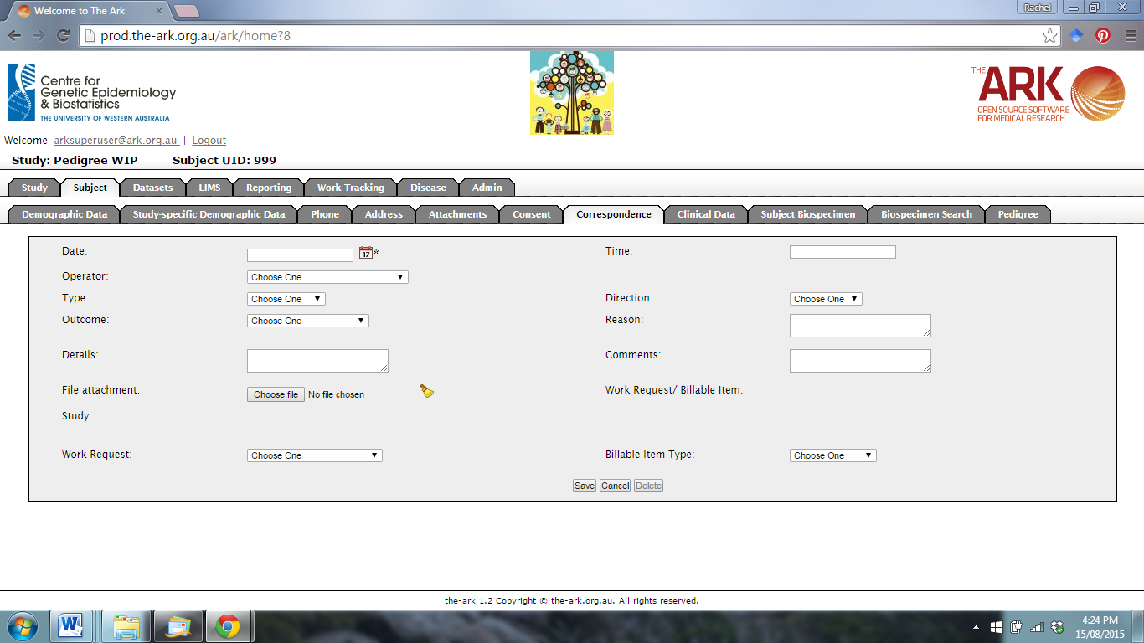

When you are finished, click Save.